**Plan for Web Cartography**

Main functionality:

Fullscreen Leaflet web application

* Main dataset: *Fernwanderwege_Swabonia_points.json,* this file includes 45.000 points of GPS measurement points along hiking trials. Each point has an elevation value and a name value of the hiking trial
* Research showed that that that many markers cost high performance resources. Thus I propose this solution of Circle Markers, as recommended by the top comment: (<https://stackoverflow.com/questions/43015854/large-dataset-of-markers-or-dots-in-leaflet>)
* Each point of the *Fernwanderwege_Swabonia_points.json* should be colour coded according to its elevation value (5 classes)

Each point of the *Fernwanderwege_Swabonia_points.json* should generate a popup when hovering over the point, displaying the elevation value and the name value

Additional datasets:

* *Fernwanderwege_Swabonia_Paths.geojson* shows the same hiking paths as the main dataset but as lines. When clicking on one of the points of the *Fernwanderwege_Swabonia_points.json* dataset, the corresponding hiking path line from this dataset should appear, revealing the whole hiking path of which a single point just got clicked. (The connecting attribute between the datasets is the name value).
* Additionally, the name of the hiking path should appear, and maybe zoom in/out to the bbox of the hiking path feature
* Swaboni.border.json = border polygon for AOI
* Main Basemap: <https://leaflet-extras.github.io/leaflet-providers/preview/#filter=Esri.WorldShadedRelief>
* Basemap 2: <https://leaflet-extras.github.io/leaflet-providers/preview/#filter=Thunderforest.Outdoors>
* Basemap 3: <https://leaflet-extras.github.io/leaflet-providers/preview/#filter=Esri.WorldImagery>

Additional functionality:

* Layer control for basemaps and feature layers
* Restrict zoom out to extend of map features
* Title of the application: Long distance hiking trials in Bavaria, Germany
* Space for Imprint and description of the application (e.g. sidebar)

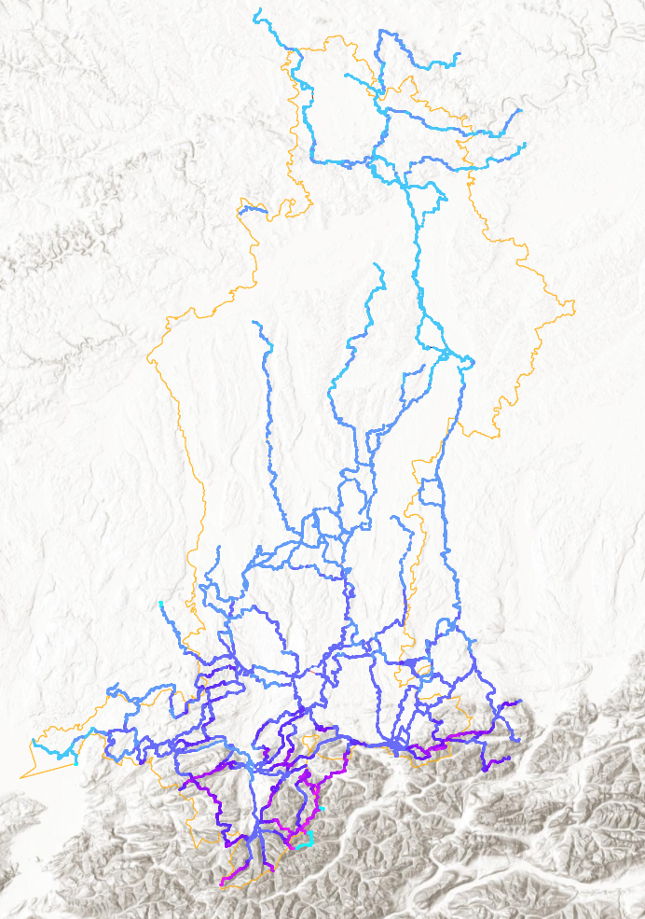

**Notes:**

**Choice of Mapping Library**

**Choice of Data Layers**

**Choice of Basemaps**

**Legend**

Credits > tooltip (Leaflet)can also be added